**RESTAURANT RESERVATION APP** by Fay Camille D. Llanera

**Description:** Restaurant Reservation App allows user to view list of diners’ name and make reservations online. Additionally, users can also search a diner to view basic information like address and contact number. Lastly, users can also rate it based on their dining experiences.

**Features: Languages: Database:**

Login Python PostgreSQL

View Restaurant Information JavaScript

Reservation HTML

Search Restaurant

Rating

Logout

**USE-CASE DIAGRAM:**

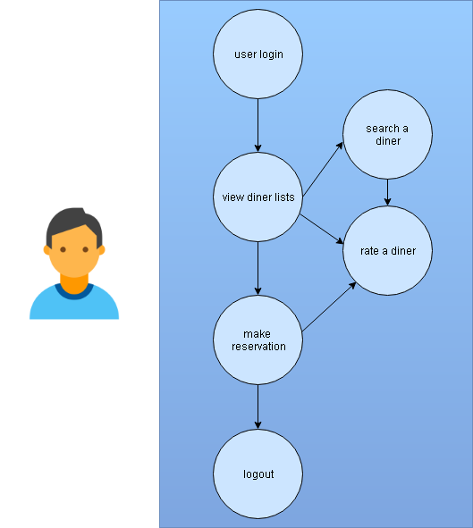

**CLASS DIAGRAM:**

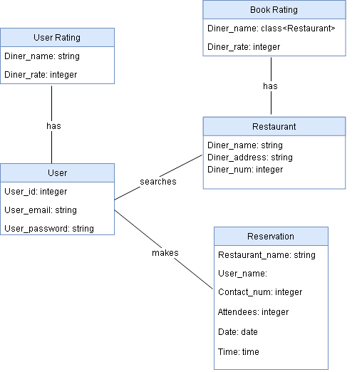

N

N

1

1

N

1

N

1

**ERD – Diagram:**

